**Event Loop**

Node.js is a single-threaded event-driven platform that is capable of running non-blocking, asynchronously programming. These functionalities of Node.js make it memory efficient. The event loop allows Node.js to perform non-blocking I/O operations despite the fact that JavaScript is single-threaded. It is done by assigning operations to the operating system whenever and wherever possible.

Most operating systems are multi-threaded and hence can handle multiple operations executing in the background. When one of these operations is completed, the kernel tells Node.js and the respective callback assigned to that operation is added to the event queue which will eventually be executed.

**Features of Event Loop:**

* Event loop is an endless loop, which waits for tasks, executes them and then sleeps until it receives more tasks.
* The event loop executes tasks from the event queue only when the call stack is empty i.e. there is no ongoing task.
* The event loop allows us to use callbacks and promises.
* The event loop executes the tasks starting from the oldest first.

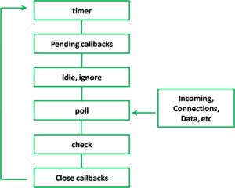

The diagram shows a simplified overview of the event loop order of operations: